* 1. ab is not in A because there are more b in second half [a | b] or bb which is equal
     1. Adv picks p
     2. I pick s∊A, S = $a^{i}ba^{i}b$
     3. Adv chops S = uvwxy, |vwx| <= p |vx| > 0
     4. I pick i = 0, $uv^{i}wx^{i}y$ = $a^{P-1}a^{i}ba^{i}a^{P-1}b$ = $a^{P-1+i}ba^{P-1+i}b$
     5. Both sides are equal, i win
  2. 1. Adv picks p
     2. I pick s∊A, S = $a^{P}b^{P}c^{P*P}$
     3. Adv chops S = uvwxy, |vwx| <= p |vx| > 0
     4. I pick i = 1, vx contains some a’s but not c’s, b is barrier, then $uv^{1}wx^{1}y$ has a least 1 a but has 1 c



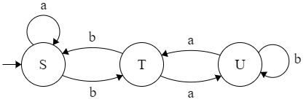

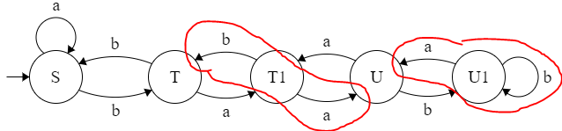

The chain will just get bigger but will stay the same shape. If you replace a single terminal with a new one and link that ner terminal back and to the original destination, it becomes a new link.

1. abba will fail but abab will be accepted. Insert odd strings to mess up the palindrome.

S -> aSa | bSb | aAb | bAa

A -> Aa | Ab | ε